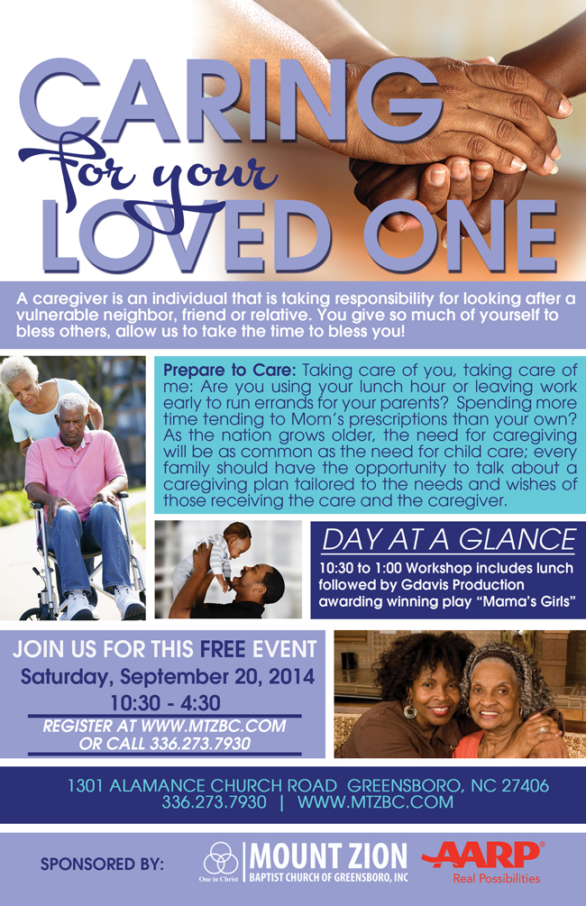
Caregiver Round-Table Luncheon: This session will provide caregivers the opportunity to fellowship with other caregivers and openly share their concerns and freely discuss their needs over lunch.

Join us for this FREE event
Saturday October 3, 2015
11:00am-1:00pm

DAY AT A GLANCE
11:00am-1:00pm
Caregiver group discussion during lunch.
Sponsored By: Mount Zion Baptist Church of Greensboro, Inc Health and Wellness Ministry
and AARP Real Possibilities

Mount Zion Baptist Church of Greensboro, Inc./AARP
Caring For Your Loved One: Caregiver Round-Table Luncheon
Saturday October 3, 2015
11:00 a.m. – 1:00 p.m.
Registration Information

Contact Information

Name: ____________________________________________________

Preferred Email Address: _____________________________________

Preferred Phone Number: _____________________________________

Mailing Address: ____________________________________________

Caregiver Information

A caregiver is an individual that is taking responsibility for looking after a vulnerable neighbor, friend or relative

Are you a caregiver (Please Check): Yes ____ No: ____

Today’s Date: September 2, 2015
Desired Air Date: September 13, 2015
Desired End Air Date: September 27, 2015
Event Date: October 3, 2015
ZNN and Website Script:
Are you an individual who is responsible for taking care of a vulnerable neighbor, relative or friend? If so, please join the Health and Wellness Ministry in partnership with AARP on Saturday October 3rd for a Caregiver Round-Table Luncheon. During this session, caregivers will have an opportunity to fellowship with other caregivers and openly share their concerns and freely discuss their needs over lunch. Registration is required for this event

